☁
CLOUD COMPUTING
UNIT:- 1

1. Cloud Computing Fundamentals

Cloud computing is a technology that lets people use computer resources like servers, storage, networks, applications, and services through the internet whenever they need them. These resources can be started or stopped quickly with very little effort. Instead of buying and maintaining their own computers and servers, people and companies use cloud services from a cloud provider and pay only for the resources they use.

Essential Characteristics
- On-Demand Self-Service: Users can provision computing capabilities automatically without requiring human interaction with the provider.
- Broad Network Access: Services are available over the network and accessed through standard mechanisms via laptops, mobiles, and tablets.
- Resource Pooling: Computing resources are pooled to serve multiple consumers using a multi-tenant model, with resources dynamically assigned.
- Rapid Elasticity: Resources can be elastically provisioned and released to scale rapidly outward or inward with demand.
- Measured Service: Resource usage is monitored, controlled, and reported, providing transparency for both provider and consumer.
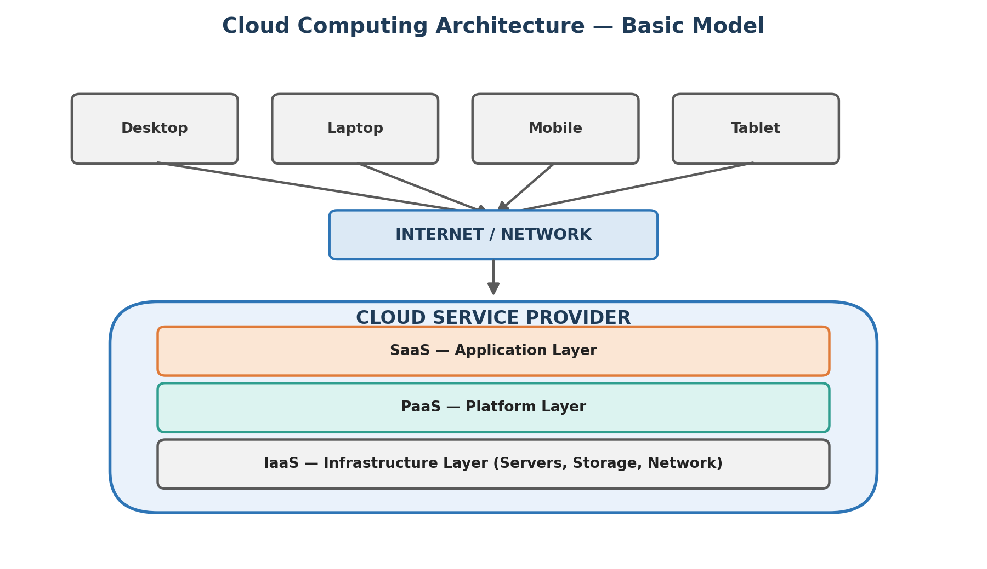

2. History of Cloud Computing
Although cloud computing became mainstream in the 2000s, its conceptual roots trace back several decades. Understanding this evolution helps explain why cloud computing developed the way it did.
Key Milestones
- 1960s: Computer scientist J.C.R. Licklider proposed an 'Intergalactic Computer Network,' envisioning a world where everyone could access programs and data from any location — an early conceptual seed of the cloud.
- 1999: Salesforce.com pioneered the concept of delivering enterprise applications via a simple website, demonstrating the viability of Software as a Service (SaaS).
- 2002: Amazon began modernizing its data centers, which, after being upgraded, gave rise to the idea of offering access to virtual servers as a service — leading to Amazon Web Services (AWS).
- 2006: AWS launched Elastic Compute Cloud (EC2) and Simple Storage Service (S3), offering true Infrastructure as a Service (IaaS) to the public for the first time.
- 2008: Google launched Google App Engine, a Platform as a Service (PaaS) offering that let developers build and host applications on Google's infrastructure.
- 2010 onward: Microsoft Azure was launched, and cloud adoption accelerated rapidly across enterprises, governments, and educational institutions worldwide.

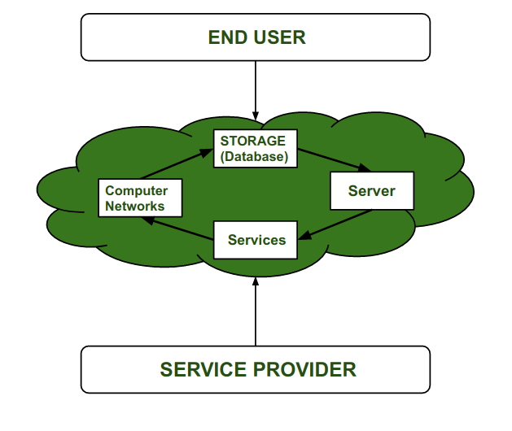

3. Definition of Cloud Computing
Several standard bodies and organizations have formally defined cloud computing. The most widely accepted definition is provided by the National Institute of Standards and Technology (NIST), USA:
“Cloud computing is a model for enabling ubiquitous, convenient, on-demand network access to a shared pool of configurable computing resources that can be rapidly provisioned and released with minimal management effort or service-provider interaction.” — NIST Definition of Cloud Computing (paraphrased)

In simpler terms, cloud computing means using someone else's computers — housed in secure, remote data centers — to store data and run applications over the internet, rather than relying solely on a local computer or personal server.
- Delivery of computing services (servers, storage, databases, networking, software) over the internet.
- Follows a pay-per-use model, similar to electricity billing.
- Eliminates the need for organizations to buy, own, and maintain physical infrastructure.
- Provides flexibility, scalability, and remote accessibility from anywhere, anytime.

4. Types of Cloud Deployment
Cloud deployment models describe how cloud infrastructure is made available to users, based on ownership, scale, and access. The three primary models are Public, Private, and Hybrid cloud.
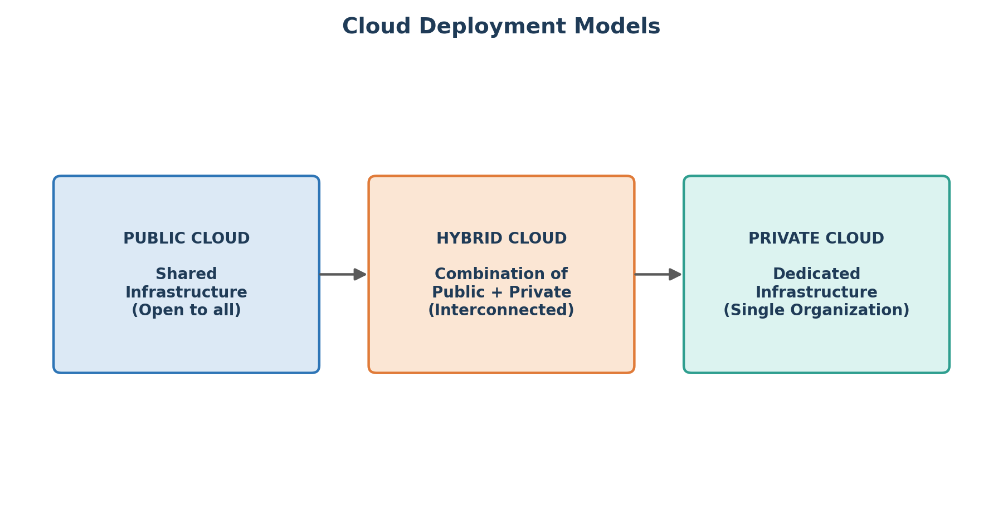.

Public Cloud
- Public clouds are managed by third parties which provide cloud services over the internet to the public, these services are available as pay-as-you-go billing models.
- They offer solutions for minimizing IT infrastructure costs and become a good option for handling peak loads on the local infrastructure. Public clouds are the go-to option for small enterprises, which can start their businesses without large upfront investments by completely relying on public infrastructure for their IT needs.
- The fundamental characteristics of public clouds are multitenancy. A public cloud is meant to serve multiple users, not a single customer. A user requires a virtual computing environment that is separated, and most likely isolated, from other users
Example: Public Cloud
Amazon Web Services (AWS), Microsoft Azure, and Google Cloud Platform (GCP) all offer public cloud services used by millions of businesses worldwide.

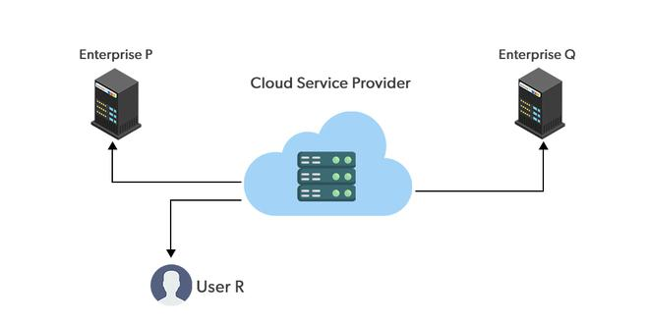

Private Cloud
- Private clouds are distributed systems that work on private infrastructure and provide the users with dynamic provisioning of computing resources. Instead of a pay-as-you-go model in private clouds, there could be other schemes that manage the usage of the cloud and proportionally billing of the different departments or sections of an enterprise. Private cloud providers are HP Data Centers, Ubuntu, Elastic-Private cloud, Microsoft, etc.
Example: Private Cloud
A large bank may run its core-banking software on a private cloud built with VMware or OpenStack to keep sensitive customer financial data fully under its own control.

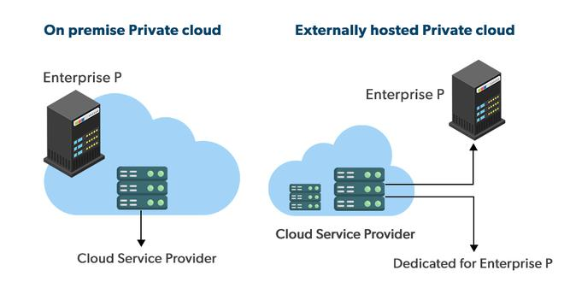

Hybrid Cloud
- A hybrid cloud is a heterogeneous distributed system formed by combining facilities of the public cloud and private cloud. For this reason, they are also called heterogeneous clouds.
- A major drawback of private deployments is the inability to scale on-demand and efficiently address peak loads. Here public clouds are needed. Hence, a hybrid cloud takes advantage of both public and private clouds.
Example: Hybrid Cloud
An e-commerce company may keep customer payment data on a private cloud, while using a public cloud to handle the surge in website traffic during a major sale event, such as Black Friday.

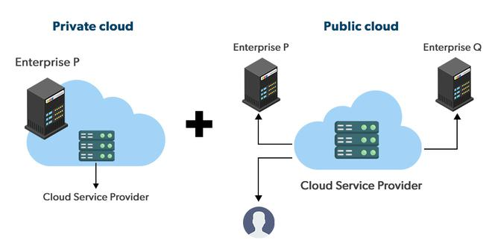

5. Applications of Cloud Computing
Cloud computing has become foundational across nearly every industry due to its flexibility, scalability, and cost efficiency. Some major real-world applications include:
- Data Storage & Backup: Services like Google Drive, Dropbox, and OneDrive allow users to store and access files from any device, anywhere.
- Streaming Services: Platforms such as Netflix and Spotify stream video and audio content directly from cloud servers.
- Email & Productivity Tools: Cloud email services (Gmail, Outlook 365) and productivity suites (Google Workspace, Microsoft 365) run entirely in the cloud.
- Enterprise Applications (CRM/ERP): Businesses use platforms such as Salesforce (CRM) and SAP to manage customer relationships and enterprise operations without local installations.
- AI & Machine Learning: Cloud infrastructure provides on-demand computational power needed to train complex machine learning and AI models (e.g., Google Colab, AWS SageMaker).
- Healthcare: Hospitals use cloud platforms to securely store and share patient records (Electronic Health Records) across departments and locations.
- E-Learning: Educational platforms like Google Classroom and Zoom rely on cloud infrastructure to support remote learning at scale.
- Web & App Hosting: Startups and developers deploy websites and mobile applications on cloud servers instead of investing in physical infrastructure.

6. Challenges of Cloud Computing
Despite its advantages, cloud computing presents several challenges that organizations must carefully address before and during adoption.
- Data Security & Privacy: Storing sensitive data on third-party servers raises concerns about unauthorized access, data breaches, and compliance with regulations.
- Internet Dependency: Cloud services require a stable, high-speed internet connection; any downtime directly disrupts access to critical applications.
- Downtime & Reliability: Cloud providers can experience outages, and even brief downtime can significantly impact business operations.
- Vendor Lock-In: Moving large volumes of data between different cloud providers can be technically complex and, once locked into one provider's ecosystem, costly to migrate away from.
- Data Governance & Compliance: Storing data across multiple countries can create legal and regulatory challenges (e.g., GDPR in the EU) regarding where data is physically held.
- Cost Management: While pay-as-you-go reduces upfront costs, uncontrolled or unmonitored usage can lead to unexpectedly high recurring bills.
- Limited Control: Organizations have limited visibility and control over the underlying infrastructure managed by the cloud provider.

7. Types of Cloud Computing (Service Models)
Cloud services are broadly classified into three service models, often visualized as layers stacked on top of physical infrastructure, each offering a different degree of control versus convenience.
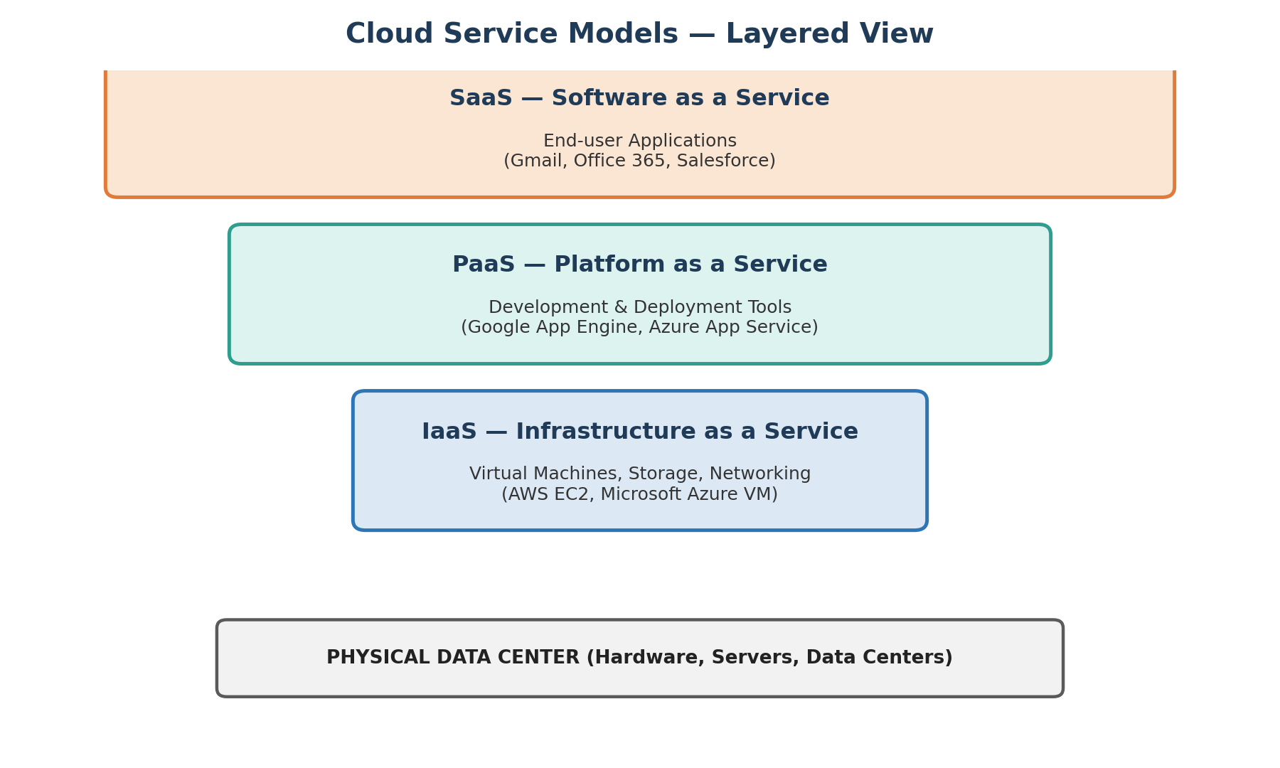

Infrastructure as a Service (IaaS)
IaaS provides virtualized computing resources such as servers, storage, and networking over the internet on a pay-as-you-go basis. It offers the highest level of control and flexibility, acting as the digital foundation for your IT operations.
How it works: It is like renting an empty plot of land. The provider gives you the space and the utilities (hardware, network, storage), but you are entirely responsible for building the house (installing the OS, middleware, and applications).
Characteristics:
- Eliminates the capital expense of buying physical servers.
- Offers complete control over operating systems, applications, and development frameworks.
- Resources can be scaled up or down instantly based on traffic spikes.
Real-World Use Case: A tech startup experiencing rapid growth can use IaaS to instantly increase their server capacity to handle web traffic without needing to purchase, house, or wire expensive physical hardware.
Target Audience: IT Administrators, Network Architects, and DevOps teams.
Example: IaaS
Amazon Web Services (AWS EC2), Microsoft Azure (Virtual Machines), Google Compute Engine (GCE), DigitalOcean.

Platform as a Service (PaaS)
PaaS offers a complete, managed cloud environment specifically designed for developing, testing, running, and managing applications. It abstracts the underlying infrastructure so developers can focus purely on writing code.
How it works: It is like renting an unfurnished house. The foundation, plumbing, and electricity are already built and maintained by the landlord; you just need to bring your furniture and decorate (write and deploy your code).
Characteristics:
- Acts as a complete toolkit for developers, providing pre-built tools, libraries, and development environments.
- The cloud provider handles all backend infrastructure, including server provisioning, OS patching, and network routing.
- Automates deployment workflows and allows for easy team collaboration.
Real-World Use Case: A software development team building a mobile app can use PaaS to write their code and automatically connect it to managed databases and authentication services without ever having to configure a backend server.
Target Audience: Software Developers and Application Delivery Teams.
Example: PaaS
AWS Elastic Beanstalk, Google App Engine, Heroku, Microsoft Azure App Service.

Software as a Service (SaaS)
SaaS is the most user-friendly and widely used cloud model. It delivers fully functional, ready-to-use software applications over the internet, typically on a subscription basis.
How it works: It is like staying in a fully furnished, serviced hotel room. Everything is provided, maintained, and cleaned for you; you simply walk in and use it.
Characteristics:
- Applications are ready to use immediately directly through a web browser or mobile app.
- The cloud provider handles absolutely everything: infrastructure, software updates, bug fixes, and security maintenance.
Real-World Use Case: A global sales team uses a cloud-based CRM to track leads and communicate with clients. They simply log in via their browsers; they don't need to worry about where the data is hosted or how the software is updated.
Target Audience: End-users, Business Professionals, and Consumers.
Example: SaaS
Salesforce, Google Workspace (Gmail, Docs), Microsoft 365, Zoom, Slack.

Basis Of | IaaS | PaaS | SaaS
Access | IaaS gives access to the resources like virtual machines and virtual storage. | PaaS gives access to run time environment to deployment and development tools for application. | SaaS gives access to the end user.
Model | It is a service model that provides virtualized computing resources over the internet. | It is a cloud computing model that delivers tools that are used for the development of applications. | It is a service model in cloud computing that hosts software to make it available to clients.
Technical understanding. | It requires technical knowledge. | Some knowledge is required for the basic setup. | There is no requirement about technicalities company handles everything.
Popularity | It is popular among developers and researchers. | It is popular among developers who focus on the development of apps and scripts. | It is popular among consumers and companies, such as file sharing, email, and networking.
Percentage rise | It has around a 12% increment. | It has around 32% increment. | It has about a 27 % rise in the cloud computing model.
Usage | Used by the skilled developer to develop unique applications. | Used by mid-level developers to build applications. | Used among the users of entertainment.
Cloud services. | Amazon Web Services, sun, vCloud Express. | Facebook, and Google search engine. | MS Office web, Facebook and Google Apps.
Enterprise services. | AWS virtual private cloud. | Microsoft Azure. | IBM cloud analysis.
Outsourced cloud services. | Salesforce | Force.com, Gigaspaces. | AWS, Terremark
User Controls | Operating System, Runtime, Middleware, and Application data | Data of the application | Nothing
Others | It is highly scalable and flexible. | It is highly scalable to suit the different businesses according to resources. | It is highly scalable to suit the small, mid and enterprise level business

8. Public Cloud vs. Private Cloud (Comparison Table)
1. Public Cloud:
Computing in which service provider makes all resources public over the internet. It is connected to the public Internet. Service provider serves resources such as virtual machines, applications, storage, etc to the general public over the internet. It may be free of cost or with minimal pay-per-usage. It is available for public display, Google uses the cloud to run some of its applications like google docs, google drive or YouTube, etc.
It is the most common way of implementing cloud computing. The external cloud service provider owns, operates, and delivers it over the public network.
It is best for the companies which need an infrastructure to accommodate a large number of customers and work on projects which have diverse organizations i.e. research institutions and NGOs etc.
Public Cloud Advantages:
- Scalability: Public cloud services are designed to be scalable, which means you can easily add or remove resources as needed.
- Cost-Effective: Public cloud providers typically offer a pay-as-you-go model, which allows you to only pay for the resources you use, making it cost-effective.
- Accessibility: Public cloud services are accessible from anywhere with an internet connection, which makes it easy to access data and applications from anywhere in the world.
- Reliability: Public cloud providers usually have multiple data centers across different locations, which ensures high availability and reliability.
Public Cloud Disadvantages:
- Security: Since public cloud services are available to anyone with an internet connection, there is a risk of unauthorized access or data breaches.
- Control: Public cloud providers have control over the infrastructure and services, which means you have limited control over how your data is stored and managed.
- Compliance: Compliance requirements can be a challenge for public cloud users since they have to comply with the regulations and standards that apply to the cloud provider.
2. Private Cloud:
Computing in which service provider does not makes all resources public over the internet. It only supports connectivity over the private network. It has only authentic users and single-occupant architecture. Google back-end data of the applications like Google Drive, Google docs, YouTube, etc are not available to the public, these types of data and applications run on a private cloud.
The infrastructure and services are maintained and deployed over a private network; hardware and software are dedicated only to a private company i.e. members of the special entity.
It is best for the companies which need an infrastructure that has high performance, high security, and privacy due to its best adaptability and flexibility.
Private Cloud Advantages:
- Control: Private cloud users have full control over the infrastructure and services, which means they can customize the environment to their specific needs.
- Security: Private cloud services are typically more secure since they are only accessible to authorized users.
- Compliance: Private cloud users have more control over compliance requirements since they can customize the environment to meet specific regulatory requirements.
- Customization: Private cloud users can customize the environment to their specific needs, which means they can optimize performance and efficiency.
Private Cloud Disadvantages:
- Cost: Private cloud services can be more expensive than public cloud services since they require a dedicated infrastructure.
- Maintenance: Private cloud users are responsible for maintaining and updating the infrastructure, which can be time-consuming and costly.
- Scalability: Private cloud services can be less scalable than public cloud services, which means they may not be able to handle sudden spikes in demand.

